### Viewing Consent History

Clicking **View Consent History** displays an audit trail of all changes made to a patient’s consent status.

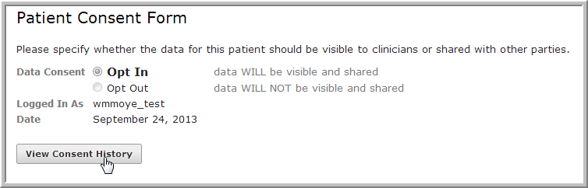

Note: Auditors have view-only access to the current consent selection; changes must be made by a Clerk or Administrator.

The *Patient Consent Audit Log* lists all changes made to opt-in/opt-out status; the name and user group of the user who made the change; and the date and time of the change.

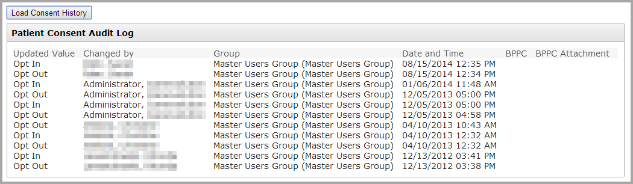

The Opt in/Opt out status of a patient can be changed using Basic Patient Privacy Consents (BPPC). When consent status is changed using data from an outside source (such as XDS), a BPPC document will be generated. Links to those documents will appear in the *BPPC* and *BPPC Attachment* columns